***DataLock : Encrypt, Protect***

***A***

***Project Report***

*submitted in partial fulfillment of the*

*requirements for the award of the degree of*

**BACHELOR OF TECHNOLOGY**

**in**

**COMPUTER SCIENCE & ENGINEERING**

**by**

|  |  |
| --- | --- |
| **Name** | **Roll No.** |
| **Aadeesh Jain** | **R2142220375** |
|  |  |
|  |  |
|  |  |



**School of Computer Science**

**University of Petroleum & Energy Studies**

**Bidholi, Via Prem Nagar, Dehradun, Uttarakhand**

**November– 2024**

**CANDIDATE’S DECLARATION**

I/We hereby certify that the project work entitled **“DataLock: Encrypt, Protect”** in partial fulfilment of the requirements for the award of the Degree of BACHELOR OF TECHNOLOGY in COMPUTER SCIENCE AND ENGINEERING with specialization in CYBER SECURITY AND FORENSICS and submitted to the Department of Systemics, School of Computer Science, University of Petroleum & Energy Studies, Dehradun, is an authentic record of my work carried out during a period from **September**, **2024** to **November**, **2024** under the supervision of **Dr. Narendra Kumar Devangan**.

The matter presented in this project has not been submitted by me for the award of any other degree of this or any other University.

**(Aadeesh Jain)**

**Roll No. R2142220375**

**ACKNOWLEDGEMENT**

We wish to express our deep gratitude to our guide **Dr. Narendra Kumar Devangan**, for all advice, encouragement and constant support he has given us throughout our project work. This work would not have been possible without his support and valuable suggestions.

We are also grateful to Dean SoCS UPES for giving us the necessary facilities to carry out our project work successfully. We also thanks to our Course Coordinator, **Mrs. Gaytri Bakshi** for providing timely support and information during the completion of this project.

We would like to thank all our friends for their help and constructive criticism during our project work. Finally, we have no words to express our sincere gratitude to our parents who have shown us this world and for every support they have given us.

|  |  |  |  |  |
| --- | --- | --- | --- | --- |
| **Name** | **Aadeesh Jain** |  |  |  |
| **Roll No.** | **R2142220375** |  |  |  |

**ABSTRACT**

The encryption and decryption webpage project aims to create an interactive and user-friendly platform to demonstrate the fundamentals of cryptographic techniques. With the increasing importance of data security in today's digital age, understanding encryption is crucial. This project provides an educational tool designed to simplify and showcase how basic encryption and decryption processes work. Users can choose between operations (encryption or decryption) and select from commonly known techniques such as Caesar Cipher, XOR Encryption, and Base64 Encoding.

The platform is entirely browser-based, leveraging HTML, CSS, and JavaScript, and does not require any backend integration. Users input their data and, depending on the selected technique, a key if necessary. The application then processes the input and provides the result in real-time. This simplicity ensures that even individuals with minimal technical expertise can explore and understand encryption concepts.

The webpage's responsive design ensures accessibility across devices, while built-in error handling validates inputs to prevent incorrect processing. Beyond being a practical demonstration tool, the project serves as a stepping stone for further exploration into more complex cryptographic methods. By making encryption approachable, this project fosters learning and curiosity about the principles that secure our digital world.

**TABLE OF CONTENTS**

S.No.

Introduction

2. Software Requirements Specification6

* 1. Introduction
  2. System Analysis
  3. Functional Requirements
  4. System Design
  5. Constraints
  6. Assumptions and Dependencies
  7. Acceptance Criteria
  8. Future Enhancements
  9. Conclusion

3. Source code

4. Output Screen

**INTRODUCTION**

The encryption and decryption webpage is a robust and user-friendly application developed to make the concepts of cryptography more accessible to users of all skill levels. In the modern digital era, where data security is of utmost importance, encryption plays a pivotal role in safeguarding sensitive information. Despite its significance, the foundational techniques of encryption often remain obscure or challenging for beginners to grasp. This project seeks to bridge that gap by offering a simple, interactive platform where users can experiment with widely used encryption techniques such as Caesar Cipher, XOR Encryption, and Base64 Encoding.

This webpage is designed to serve as both an educational tool and a practical demonstration of how cryptographic operations work. By allowing users to input data, select an encryption or decryption technique, and view the results in real time, the application demystifies the inner workings of encryption. The platform does not require any additional software or installations, as it is a lightweight, browser-based solution that leverages standard web technologies such as HTML, CSS, and JavaScript.

Whether used by students, enthusiasts, or anyone interested in understanding data security, this webpage provides an intuitive, hands-on experience. It is not only a learning tool but also an example of how even basic encryption techniques can be implemented and utilized effectively. By focusing on simplicity, accessibility, and functionality, the project aims to empower users to explore the fundamental principles of cryptography and understand its relevance in protecting data

**Software Requirements Specification**

**1.** **Introduction**

**1.1 Purpose**

The purpose of this project is to develop a simple and interactive web-based application that allows users to perform encryption and decryption operations using common techniques like Caesar Cipher, XOR Encryption, and Base64 Encoding. The application aims to demonstrate how basic encryption techniques work in a user-friendly manner.

**1.2 Scope**

This application is a lightweight, standalone webpage that:

- Enables users to select an operation (encryption or decryption).

- Allows users to choose from predefined encryption techniques.

- Accepts input text and a key (if required) from the user.

- Displays the result of the operation in real-time.

- Is intended for educational and demonstrative purposes only.

**1.3 Definitions, Acronyms, and Abbreviations**

- Caesar Cipher: A substitution cipher that shifts characters by a fixed number of positions.

- XOR Encryption: A bitwise operation that encrypts data using an XOR operation with a key.

- Base64 Encoding: A method to encode binary data as text using a base-64 representation.

**1.4 Overview**

The system includes a user interface for interaction and a JavaScript-based implementation of encryption/decryption logic. The UI and functionality are designed for accessibility and simplicity.

---

**2. System Analysis**

The encryption and decryption webpage is developed as a front-end-only application, requiring no backend or database integration. This makes it lightweight and accessible directly through any modern browser. The system is divided into several modules, including input handling, cryptographic logic, and output display. Each module has been designed to work cohesively to ensure a seamless user experience.

**Problem Statement**

Encryption is an essential aspect of data security, and understanding its fundamental techniques is vital for beginners. However, most existing tools for encryption and decryption are either overly complex or lack educational focus. This project addresses the need for a simple, interactive platform where users can learn and apply basic encryption techniques.

**Proposed Solution**

The proposed solution is a single-page application that:

- Provides a straightforward interface for selecting encryption/decryption operations and techniques.

- Validates user inputs to prevent errors during processing.

- Displays the results instantly, enabling users to experiment with different techniques and parameters.

**Feasibility Study**

1. Technical Feasibility: The application uses standard web technologies (HTML, CSS, JavaScript) that are widely supported and require no additional installations.

2. Economic Feasibility: As a front-end-only application, there are no hosting or maintenance costs aside from a basic web server.

3. Operational Feasibility: The user-friendly interface ensures that individuals with minimal technical expertise can use the application effectively.

---

**3.** **Functional Requirements**

**3.1 User Interface**

- The webpage will have a responsive design to ensure usability on different devices.

- Users will be presented with dropdowns to select the operation and encryption technique.

- Input fields will be provided for:

- Data to be encrypted/decrypted.

- A key, if required by the chosen technique.

- Results will be displayed in a designated area below the input fields.

**3.2 Core Functionality**

1. Operation Selection:

- The user can choose between encryption and decryption.

2. Technique Selection:

- Supported techniques include:

- Caesar Cipher (requires a numeric key).

- XOR Encryption (requires a numeric key).

- Base64 Encoding (key not required).

3. Input Validation:

- Ensure valid data and key input based on the selected technique.

4. Processing:

- Implement the logic for each technique based on user inputs.

- Handle errors such as invalid keys or malformed inputs.

**3.3 Non-Functional Requirements**

- The application will run entirely in the browser and does not require a backend server.

- The design will focus on simplicity and responsiveness.

- Alerts and error messages will guide users in case of invalid inputs.

---

**4.** **System Design**

**4.1 Architecture**

- Frontend: HTML, CSS, and JavaScript.

- Logic: JavaScript functions for each encryption technique.

**4.2 Key Functional Modules**

1. Input Handling:

- Accept user inputs for data and keys.

2. Encryption/Decryption Logic:

- Caesar Cipher: Shift characters based on the key.

- XOR Encryption: Apply XOR operation between character codes and the key.

- Base64 Encoding: Use built-in `btoa` and `atob` functions.

3. Output Display:

- Render the result in the designated area of the page.

4. Error Handling:

- Show alerts for missing or invalid inputs.

---

**5.** **Constraints**

- Browser Compatibility: The application must work on modern browsers (Chrome, Firefox, Edge, Safari).

- Performance: The application is lightweight and processes data in real-time.

- Security: This is a demonstration tool and is not suitable for secure data encryption.

---

**6. Assumptions and Dependencies**

- Users have a basic understanding of encryption and decryption.

- The browser supports JavaScript, `btoa`, and `atob` functions for Base64 operations.

- No backend services or database are required.

---

**7. Acceptance Criteria**

- The webpage should load correctly and display the interface as described.

- The user should be able to:

- Select encryption or decryption.

- Choose from the three provided techniques.

- Enter the required inputs and see the correct output.

- Error messages should appear for invalid inputs.

- The design should be responsive and functional across devices.

---

**8. Future Enhancements**

- Add more encryption techniques (e.g., Vigenère Cipher, AES).

- Allow users to upload and encrypt/decrypt files.

- Provide visual representations of the encryption process.

- Add multilingual support for the UI.

---

**9. Conclusion**

This project successfully provides an interactive and educational platform for demonstrating basic encryption and decryption techniques. The lightweight, browser-based application enables users to explore and understand the principles of cryptography through practical experimentation. While limited to three techniques currently, the system's modular design allows for easy expansion to include more advanced methods in the future. By combining simplicity with functionality, this application serves as a valuable resource for beginners and enthusiasts looking to delve into the world of encryption.

**Source Code**

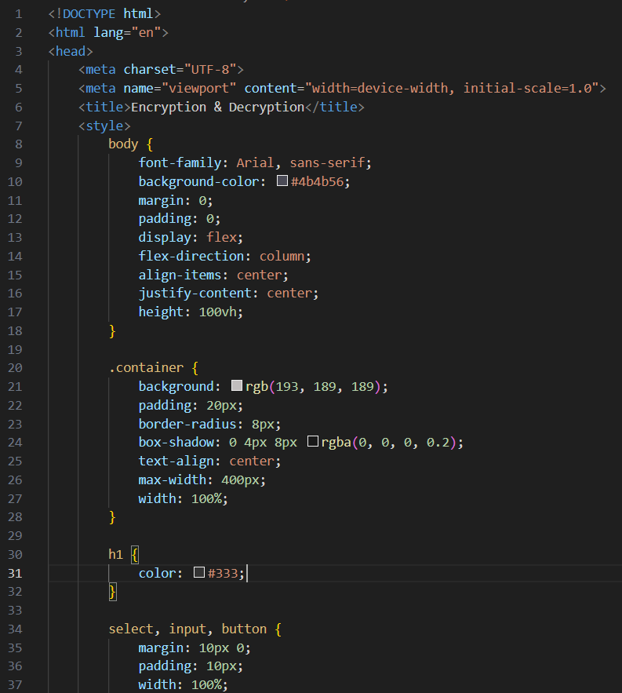

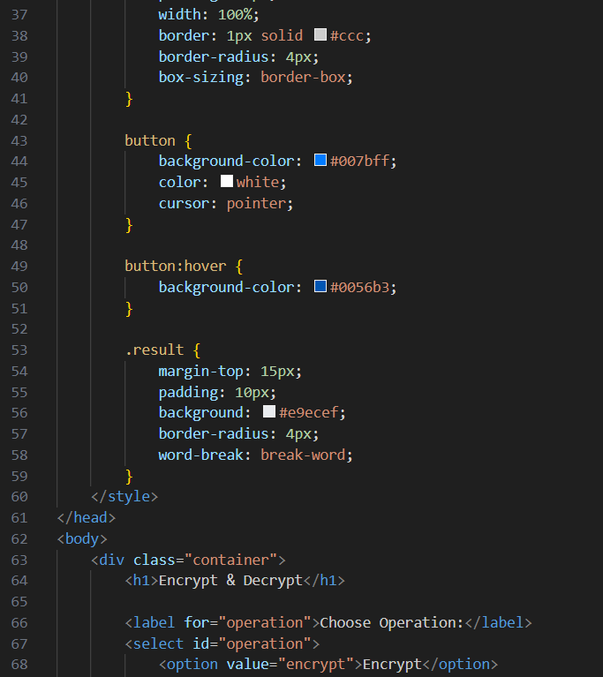

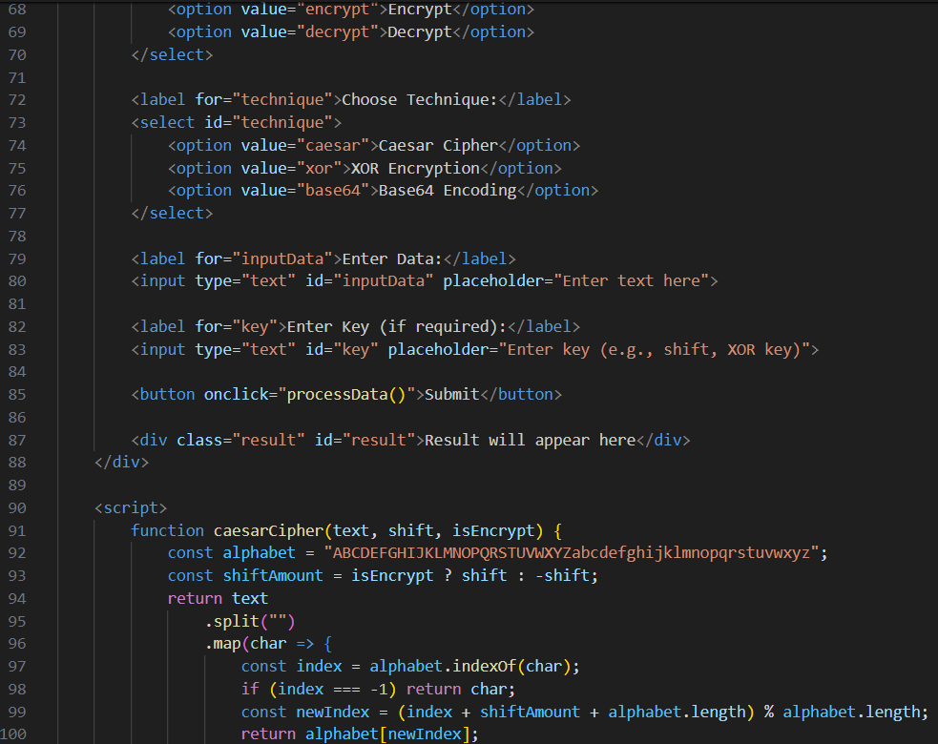

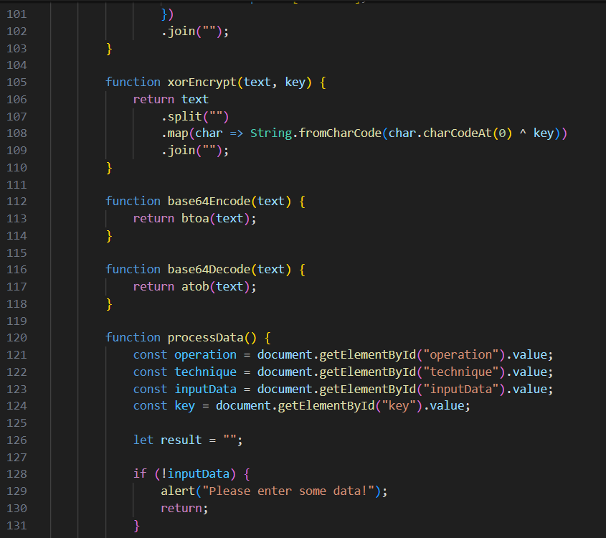

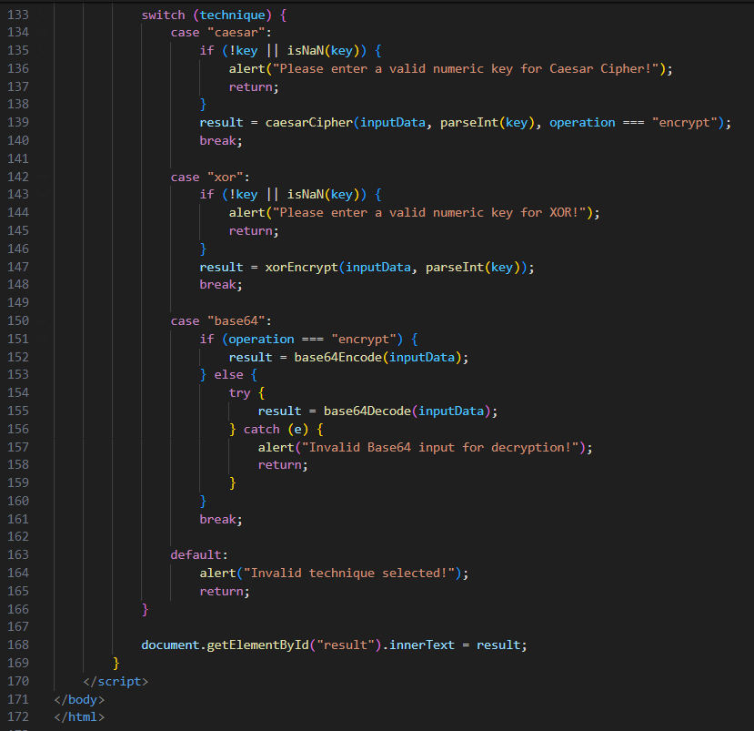

**Output Screens**

